Class Design - View

# Create Initial Design Classes

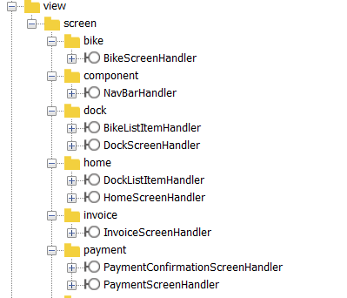

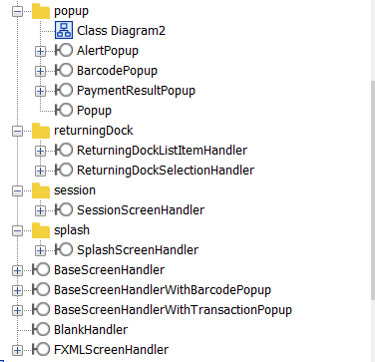

# Define Relationships Between Classes

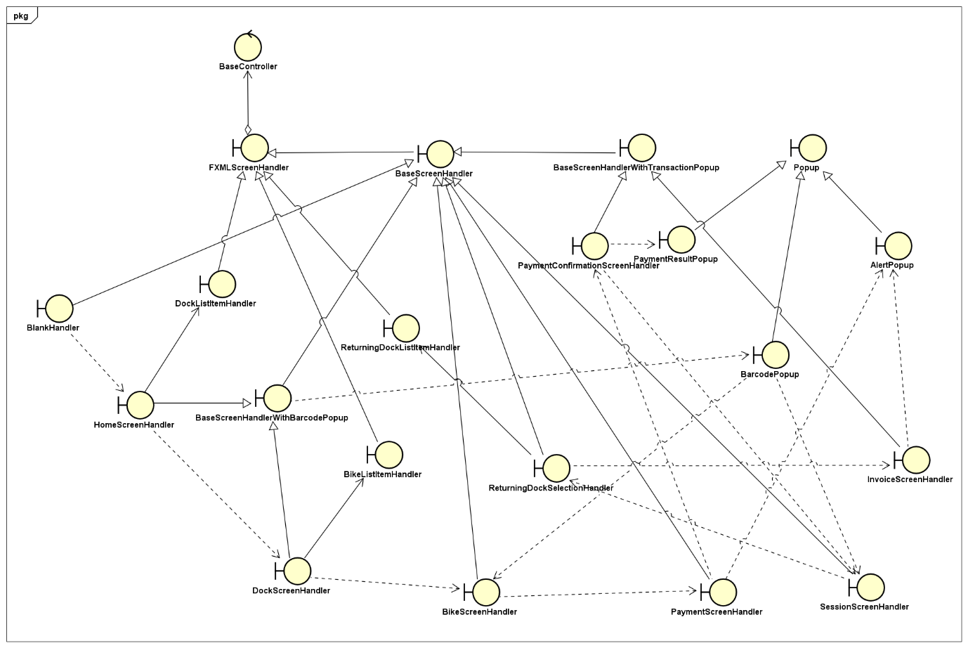

# Class Design

## Class “BikeScreenHandler”

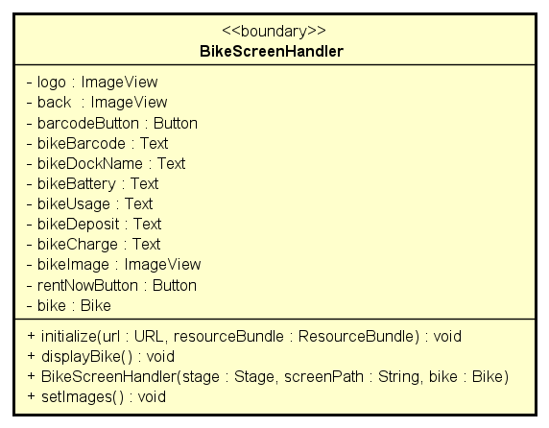

**Attribute**

|  |  |  |  |  |
| --- | --- | --- | --- | --- |
| # | Name | Data type | Default value | Description |
| 1 | logo | ImageView | NULL | Logo image fxml |
| 2 | back | imageView | NULL | Back image fxml |
| 3 | barcodeButton | Button | NULL | BarcodeButton fxml |
| 4 | bikeBarcode | Text | NULL | Bike barcode fxml |
| 5 | bikeDockName | Text | NULL | Dock name fxml |
| 6 | bikeBattery | Text | NULL | Bike battery fxml |
| 8 | bikeUsage | Text | NULL | Bike usage fxml |
| 9 | bikeDeposit | Text | NULL | Bike deposit fxml |
| 10 | bikeCharge | Text | NULL | Bike charge fxml |
| 11 | bikeImage | ImageView | NULL | Bike image |
| 12 | rentNowButton | Button | NULL | Rent button fxml |
| 13 | bike | Bike | NULL | bike |

**Operation**

|  |  |  |  |
| --- | --- | --- | --- |
| # | Name | Return type | Description |
| 1 | initialize | void | initialize |
| 2 | displayBike | void | Display bike info screen |
| 3 | setImages | void | Set bike image |

Parameter:

URL

ResourceBundle

Exception:

None

**Method**

None

**State**

None

## Class “DockScreenHandler”

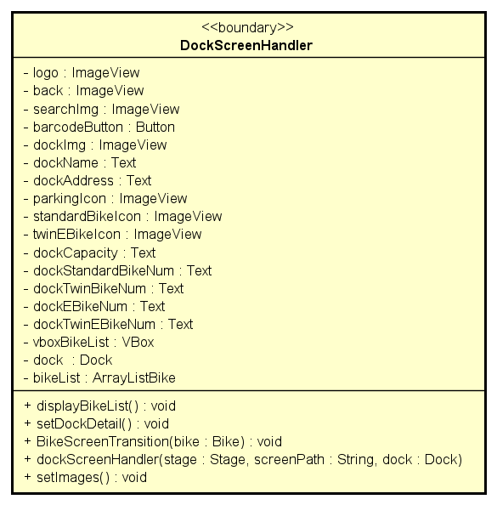

**Attribute**

|  |  |  |  |  |
| --- | --- | --- | --- | --- |
| # | Name | Data type | Default value | Description |
| 1 | logo | ImageView | NULL | Logo image fxml |
| 2 | back | imageView | NULL | Back image fxml |
| 3 | searchImg | imageView | NULL | Search image fxml |
| 4 | barcodeButton | Button | NULL | BarcodeButton fxml |
| 5 | dockName | Text | NULL | Dock name fxml |
| 6 | dockAddress | Text | NULL | Dock address fxml |
| 7 | dockImg | ImageView | NULL | Dock image fxml |
|  | parkingIcon | ImageView | NULL | Parking icon fxml |
|  | standardBikeIcon | ImageView | NULL | Standard bike icon fxml |
|  | twinEBikeIcon | ImageView | NULL | Twin bike icon fxml |
| 8 | dockStandardBikeNum | Text | NULL | Standard bike number fxml |
| 9 | dockTwinBikeNum | Text | NULL | Twin bike number fxml |
| 10 | dockEBikeNum | Text | NULL | E-bike number fxml |
| 11 | dockTwinEBikeNum | Text | NULL | Twin e-bikenumber fxml |
| 12 | vboxBikeList | VBox | NULL | Bike list fxml |
| 13 | dock | Dock | NULL | dock |
| 14 | bikeList | ArrayList<Bike> | NULL | Bike list in dock |

**Operation**

|  |  |  |  |
| --- | --- | --- | --- |
| # | Name | Return type | Description |
| 1 | displayBikeList | void | Display bike list |
| 2 | setDockDetail | void | Set dock detail |
| 3 | BikeScreenTransition | void | Transition to bike screen |
| 4 | setImages | void | Set dock image |

Parameter:

bike

Exception:

None

**Method**

None

**State**

None

## Class “BikeListItemHandler”

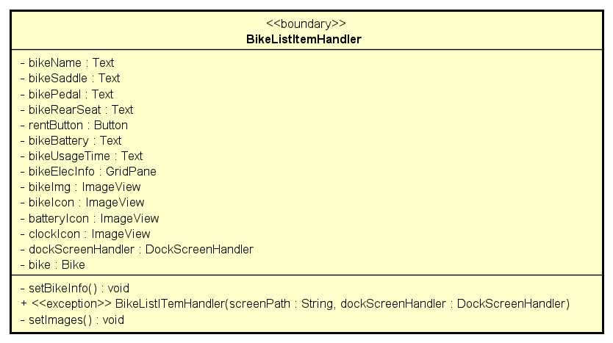

**Attribute**

|  |  |  |  |  |
| --- | --- | --- | --- | --- |
| # | Name | Data type | Default value | Description |
| 1 | bikeImg | ImageView | NULL | Bike image fxml |
| 2 | bikeIcon | imageView | NULL | Bike image fxml |
| 3 | rentButton | Button | NULL | Rent button fxml |
| 4 | bikeName | Text | NULL | Bike name fxml |
| 5 | bikeSaddle | Text | NULL | Bike saddle fxml |
| 6 | bikePedal | Text | NULL | Bike pedal fxml |
| 7 | bikeRearSeat | Text | NULL | Bike rear seat fxml |
| 8 | dockScreenHandler | DockScreenHandler | NULL | object |
| 9 | bike | Bike | NULL | object |

**Operation**

|  |  |  |  |
| --- | --- | --- | --- |
| # | Name | Return type | Description |
| 1 | setBikeInfo | void | Set bike info |
| 2 | setImages | void | Set bike imgae in list |

Parameter:

none

Exception:

IOException

**Method**

None

**State**

None

## Class “BarcodePopup”

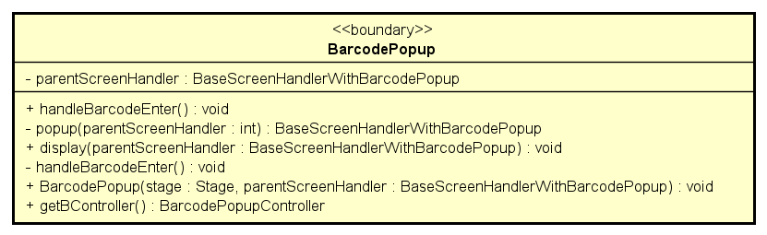

**Attribute**

|  |  |  |  |  |
| --- | --- | --- | --- | --- |
| # | Name | Data type | Default value | Description |
| 1 | parentScreenHandler | BaseScreenHandlerWithBarcodePopup | NULL | Parent screen |

**Operation**

|  |  |  |  |
| --- | --- | --- | --- |
| # | Name | Return type | Description |
| 1 | handleBarcodeEnter | void | Handle action “enter barcode” |
| 2 | popup | BaseScreenHandlerWithBarcodePopup | Popup |
| 3 | display | void | Display popup |
| 4 | handleBarcodeEnter | void | Button enter handler |
| 5 | getBController | BarcodePopupController | Get barcode |

Parameter:

parentScreenHandler

stage

Exception:

None

**Method**

None

**State**

None

## Class “DockListItemHandler”

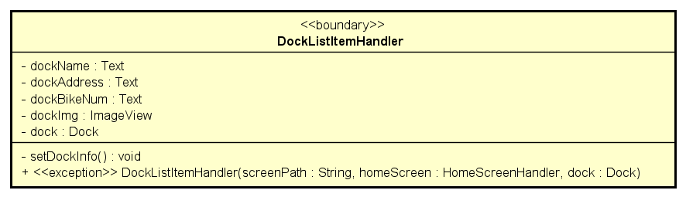

**Attribute**

|  |  |  |  |  |
| --- | --- | --- | --- | --- |
| # | Name | Data type | Default value | Description |
| 1 | dockName | Text | NULL | Dock name |
| 2 | dockAddress | Text | NULL | Dock address |
| 3 | dockBikeNum | Text | NULL | Number of bikes in dock |
| 4 | dockImg | ImageView | NULL | Dock image |
| 5 | dock | Dock | NULL | dock |

**Operation**

|  |  |  |  |
| --- | --- | --- | --- |
| # | Name | Return type | Description |
| 1 | setDockInfo | void | Set dock info |

Parameter:

none

Exception:

None

**Method**

None

**State**

None

## Class “InvoiceScreenHandler”

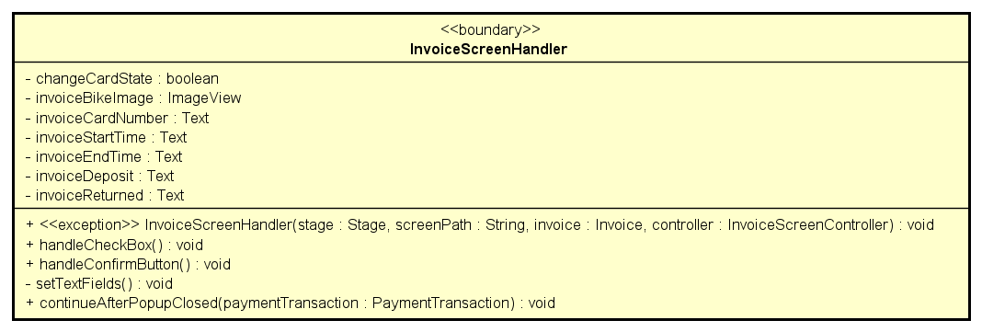

**Attribute**

|  |  |  |  |  |
| --- | --- | --- | --- | --- |
| # | Name | Data type | Default value | Description |
| 1 | changeCardState | boolean | NULL | Card state |
| 2 | invoiceBikeImage | ImageView | NULL | Bike image |
| 3 | invoiceCardNumber | Text | NULL | Invoice card number |
| 4 | invoiceStartTime | Text | NULL | Invoice start time |
| 5 | invoiceEndTime | Text | NULL | Invoice end time |
| 6 | invoiceDeposit | Text | NULL | Invoice deposit |
| 7 | invoiceReturned | Text | NULL | Invoice returned |

**Operation**

|  |  |  |  |
| --- | --- | --- | --- |
| # | Name | Return type | Description |
| 1 | handleCheckBox | void | Handle check box |
| 2 | handleConfirmButton | void | Handle confirm button |
| 3 | setTextFields | void | Set text fields |
| 4 | continueAfterPopupClosed | void | Continue program after popup close |

Parameter:

paymentTransaction

Exception:

None

**Method**

None

**State**

None

## Class “PaymentConfirmationScreenHandler”

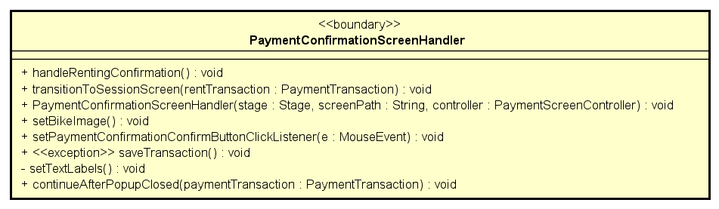

**Attribute**

|  |  |  |  |  |
| --- | --- | --- | --- | --- |
| # | Name | Data type | Default value | Description |

**Operation**

|  |  |  |  |
| --- | --- | --- | --- |
| # | Name | Return type | Description |
| 1 | handleRentingConfirmation | void | Handle confirmation action |
| 2 | transitionToSessionScreen | void | Transition to session screen |
| 3 | setBikeImage | void | Set bike image |
| 4 | setPaymentConfirmationConfirmButtonClickListener | void | Payment Confirmation Confirm Button Click Listener |
| 5 | saveTransaction | void | Save transaction |
| 6 | setTextLabels | void | Set text |
| 7 | continueAfterPopupClosed | void | Continue program after popup close |

Parameter:

rentTransaction

paymentTransaction

mouseEvent

Exception:

IOException

**Method**

None

**State**

None

## Class “PaymentScreenHandler”

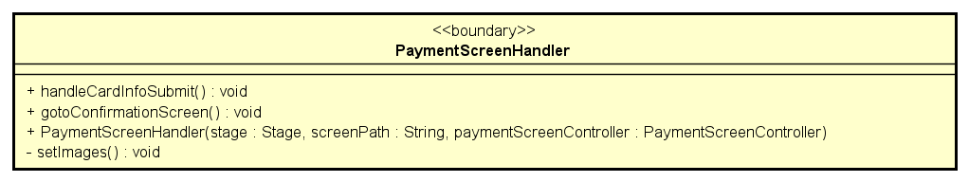

**Attribute**

|  |  |  |  |  |
| --- | --- | --- | --- | --- |
| # | Name | Data type | Default value | Description |

**Operation**

|  |  |  |  |
| --- | --- | --- | --- |
| # | Name | Return type | Description |
| 1 | handleCardInfoSubmit | void | Handle action submit card |
| 2 | gotoConfirmationScreen | void | Transition to confirmation screen |
| 3 | setImages | vodi | Set payment image |

Parameter:

None

Exception:

None

**Method**

None

**State**

None

## Class “ReturningDockListSelectionHandler”

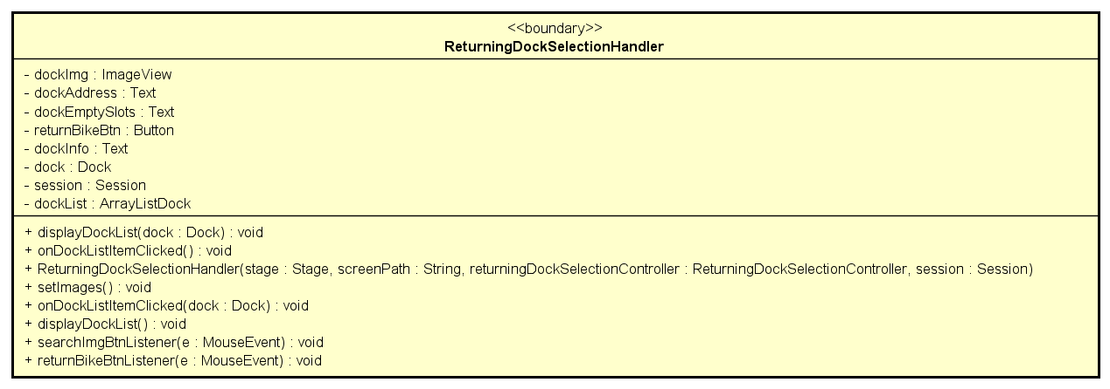

**Attribute**

|  |  |  |  |  |
| --- | --- | --- | --- | --- |
| # | Name | Data type | Default value | Description |
| 1 | dockName | Text | NULL | Dock name fxml |
| 2 | dockParkingSlot | Text | NULL | Dock parking slot fxml |
| 3 | dockImg | ImageView | NULL | Dock image fxml |
| 4 | dockInfo | Text | NULL | Dock information fxml |
| 5 | dockAdress | Text | NULL | Dock address fxml |
| 6 | dock | Dock | NULL | dock |
| 7 | session | Session | NULL | Session |
| 8 | dockList | ArrayListDock | NULL | Dock list |

**Operation**

|  |  |  |  |
| --- | --- | --- | --- |
| # | Name | Return type | Description |
| 1 | setDockInfo | void | Set dock info |
| 2 | onDockListItemClicked | void | Return dock clicked listener |
| 3 | setImages | void | Set return dock image |
| 4 | displayDockList | void | Display return dock list |
| 5 | searchImgBtnListener | void | Search image button listener |
| 6 | returnBikeBtnListener | void | Return bike button listener |

Parameter:

None

Exception:

None

**Method**

None

**State**

None

## Class “ReturningDockListItemHandler”

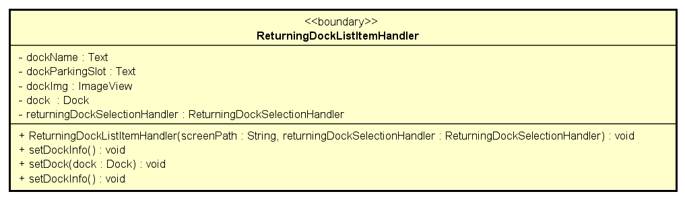

**Attribute**

|  |  |  |  |  |
| --- | --- | --- | --- | --- |
| # | Name | Data type | Default value | Description |
| 1 | dockName | Text | NULL | Dock name fxml |
| 2 | dockParkingSlot | Text | NULL | Dock address fxml |
| 3 | dockImg | ImageView | NULL | Dock image fxml |
| 4 | dock | Dock | NULL | dock |
| 5 | returningDockSelectionHandler | ReturningDockSelectionHandler | NULL | Returning Dock Selection Handler |

**Operation**

|  |  |  |  |
| --- | --- | --- | --- |
| # | Name | Return type | Description |
| 1 | setDockInfo | void | Display dock information |
| 2 | setDock | void | Display dock |

Parameter:

dock

Exception:

None

**Method**

None

**State**

None

## Class “SessionScreenHandler”

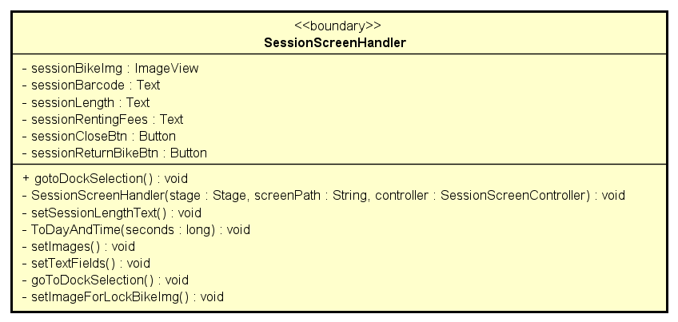

**Attribute**

|  |  |  |  |  |
| --- | --- | --- | --- | --- |
| # | Name | Data type | Default value | Description |
| 1 | sessionBikeImg | ImageView | NULL | Bike image fxml |
| 2 | sessionBarcode | Text | NULL | Session barcode fxml |
| 3 | sessionLength | Text | NULL | Session length fxml |
| 4 | sessionRentingFees | Text | NULL | Session renting fees fxml |
| 5 | sessionCloseBtn | Button | NULL | Button fxml |
| 6 | sessionReturnBikeBtn | Button | NULL | Button fxml |

**Operation**

|  |  |  |  |
| --- | --- | --- | --- |
| # | Name | Return type | Description |
| 1 | gotoDockSeletion | void | Transition to dock selection |
| 2 | setSessionLengthText | void | Set session’s length text |
| 3 | ToDayAndTime | void | Day and time conversion |
| 4 | setImages | void | Set image for session |
| 5 | setTextFields | void | Set text fields for session |
| 6 | goToDockSelection | void | Back to the dock selection |
| 7 | setImageForLockBikeImg | void | Set image for bike |

Parameter:

seconds

Exception:

None

**Method**

None

**State**

None

## Class “HomeScreenHandler”

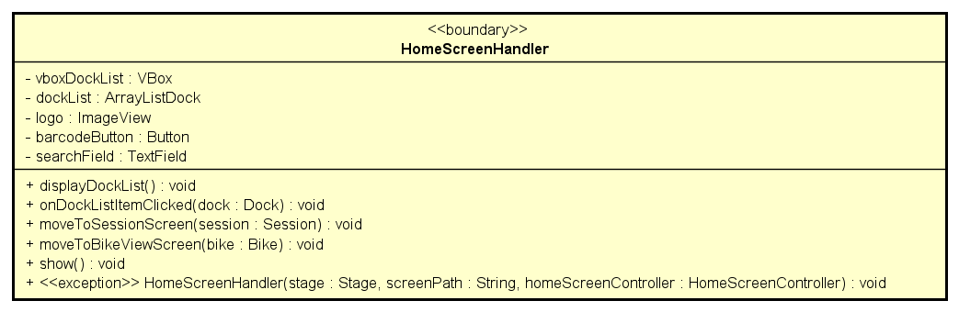

**Attribute**

|  |  |  |  |  |
| --- | --- | --- | --- | --- |
| # | Name | Data type | Default value | Description |
| 1 | vboxDockList | VBox | NULL | Vbox fxml |
| 2 | dockList | ArrayListDock | NULL | Dock list |
| 3 | logo | ImageView | NULL | Logo fxml |
| 4 | barcodeButton | Button | NULL | Barcode button fxml |
| 5 | searchField | TextField | NULL | Search field fxml |

**Operation**

|  |  |  |  |
| --- | --- | --- | --- |
| # | Name | Return type | Description |
| 1 | displayDockList | void | Display dock list |
| 2 | onDockListItemClicked | void | Dock list item clicked listener |
| 3 | moveToSessionScreen | void | Move to session screen |
| 4 | moveToBikeViewScreen | void | Move to bike view screen |
| 5 | show | void | Show screen |

Parameter:

dock

session

bike

Exception:

None

**Method**

None

**State**

None

## Class “NavBarHandler”

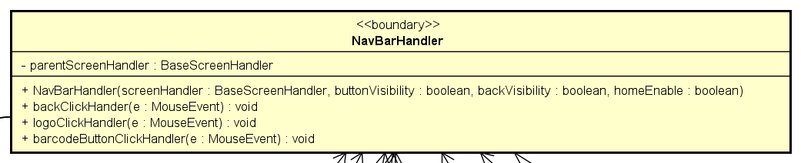

**Attribute**

|  |  |  |  |  |
| --- | --- | --- | --- | --- |
| # | Name | Data type | Default value | Description |
| 1 | parentScreenHandler | BaseScreenHandler | NULL | handler |

**Operation**

|  |  |  |  |
| --- | --- | --- | --- |
| # | Name | Return type | Description |
| 1 | backClickHandler | void | go to previous screen |
| 2 | logoClickHandler | void | go to home screen |
| 3 | barcodeButtonClickHandler | void | bring up barcode popup |

Parameter:

e – mouse event

Exception:

None

**Method**

None

**State**

None

## Class “BaseScreenHandlerWithTransactionPopup”

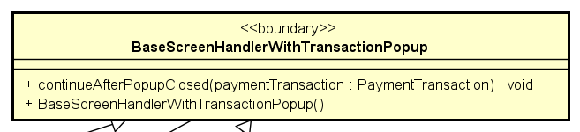

**Attribute**

None

**Operation**

|  |  |  |  |
| --- | --- | --- | --- |
| # | Name | Return type | Description |
| 1 | continueAfterPopupClosed | void | show then closed popup of payment result |

Parameter:

paymentTransaction – transaction to be shown result

Exception:

None

**Method**

None

**State**

None

## Class “PaymentResultPopup”

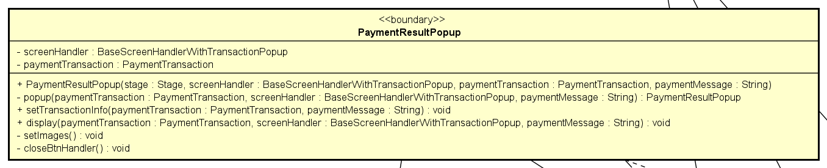

**Attribute**

|  |  |  |  |  |
| --- | --- | --- | --- | --- |
| # | Name | Data type | Default value | Description |
| 1 | screenHandler | BaseScreenHandlerWithTransactionPopup | new | handler |
| 2 | paymentTransaction | PaymentTransaction | NULL | transaction to be shown |

**Operation**

|  |  |  |  |
| --- | --- | --- | --- |
| # | Name | Return type | Description |
| 1 | setTransactionInfo | void | Display result |
| 2 | display | void | Render result |
| 3 | setImage | void | Set image for screen |
| 4 | closeBtnHandler | void | Close the popup and move to next screen |
| 5 | popup | PaymentResultPopup | Create then return popup |

Parameter:

screenHandler

paymentTransaction

paymentMessage

Exception:

None

**Method**

None

**State**

None

## Class “FXMLScreenHandler”

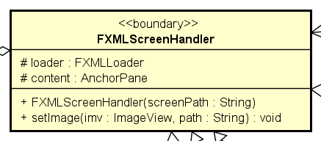

**Attribute**

|  |  |  |  |  |
| --- | --- | --- | --- | --- |
| # | Name | Data type | Default value | Description |
| 1 | loader | FXMLLoader | new |  |
| 2 | content | AnchorPane | NULL | main app anchor |

**Operation**

|  |  |  |  |
| --- | --- | --- | --- |
| # | Name | Return type | Description |
| 1 | setImage | void | set image for screen |

Parameter:

imv – image holder to be set

path – path to image

Exception:

None

**Method**

None

**State**

None

## Class “BaseScreenHandler”

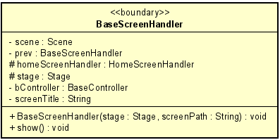

**Attribute**

|  |  |  |  |  |
| --- | --- | --- | --- | --- |
| # | Name | Data type | Default value | Description |
| 1 | scene | Scene | NULL | Scene to render |
| 2 | prev | BaseScreenHandler | NULL | Previous screen |
| 3 | homeScreenHandler | HomeScreenHandler | NULL | Home screen |
| 4 | stage | Stage | NULL | JavaFx stage |
| 5 | bController | BaseController | NULL | Controller for this screen |
| 6 | screenTitle | String | NULL | Title of this screen |

**Operation**

|  |  |  |  |
| --- | --- | --- | --- |
| # | Name | Return type | Description |
| 1 | show | void | Render the screen |

Parameter:

Exception:

None

**Method**

None

**State**

None

# Class Diagram

